Lone Ranger

Game Design Document (GDD)



***‘Defend your country and your honor’*** - you

|  |  |  |
| --- | --- | --- |
| Table of Contents  [1 Game Overview](https://n-xovwktmtjsnaxyc2mwes2xu7pohqedmdm6zjw5q-2lu-script.googleusercontent.com/userCodeAppPanel)  [2 High Concept](https://n-xovwktmtjsnaxyc2mwes2xu7pohqedmdm6zjw5q-2lu-script.googleusercontent.com/userCodeAppPanel)  [3 Synopsis](https://n-xovwktmtjsnaxyc2mwes2xu7pohqedmdm6zjw5q-2lu-script.googleusercontent.com/userCodeAppPanel)  [4 Game Objectives](https://n-xovwktmtjsnaxyc2mwes2xu7pohqedmdm6zjw5q-2lu-script.googleusercontent.com/userCodeAppPanel)  [5 Game Rules](https://n-xovwktmtjsnaxyc2mwes2xu7pohqedmdm6zjw5q-2lu-script.googleusercontent.com/userCodeAppPanel)  [6 Game Play](https://n-xovwktmtjsnaxyc2mwes2xu7pohqedmdm6zjw5q-2lu-script.googleusercontent.com/userCodeAppPanel)  [6.1 Game Controls](https://n-xovwktmtjsnaxyc2mwes2xu7pohqedmdm6zjw5q-2lu-script.googleusercontent.com/userCodeAppPanel)  [6.2 Maps](https://n-xovwktmtjsnaxyc2mwes2xu7pohqedmdm6zjw5q-2lu-script.googleusercontent.com/userCodeAppPanel)  [7 Players](https://n-xovwktmtjsnaxyc2mwes2xu7pohqedmdm6zjw5q-2lu-script.googleusercontent.com/userCodeAppPanel)  [7.1 Characters](https://n-xovwktmtjsnaxyc2mwes2xu7pohqedmdm6zjw5q-2lu-script.googleusercontent.com/userCodeAppPanel)  [7.2 Metrics](https://n-xovwktmtjsnaxyc2mwes2xu7pohqedmdm6zjw5q-2lu-script.googleusercontent.com/userCodeAppPanel)  [7.3 States](https://n-xovwktmtjsnaxyc2mwes2xu7pohqedmdm6zjw5q-2lu-script.googleusercontent.com/userCodeAppPanel)  [7.4 Weapons](https://n-xovwktmtjsnaxyc2mwes2xu7pohqedmdm6zjw5q-2lu-script.googleusercontent.com/userCodeAppPanel)  [8 NPC](https://n-xovwktmtjsnaxyc2mwes2xu7pohqedmdm6zjw5q-2lu-script.googleusercontent.com/userCodeAppPanel)  [8.1 Enemies](https://n-xovwktmtjsnaxyc2mwes2xu7pohqedmdm6zjw5q-2lu-script.googleusercontent.com/userCodeAppPanel)  [8.1.1 Enemy States](https://n-xovwktmtjsnaxyc2mwes2xu7pohqedmdm6zjw5q-2lu-script.googleusercontent.com/userCodeAppPanel)  [8.1.2 Enemy Spawn Points](https://n-xovwktmtjsnaxyc2mwes2xu7pohqedmdm6zjw5q-2lu-script.googleusercontent.com/userCodeAppPanel)  [8.2 Allies / Companions](https://n-xovwktmtjsnaxyc2mwes2xu7pohqedmdm6zjw5q-2lu-script.googleusercontent.com/userCodeAppPanel)  [8.2.1 Ally States](https://n-xovwktmtjsnaxyc2mwes2xu7pohqedmdm6zjw5q-2lu-script.googleusercontent.com/userCodeAppPanel)  [8.2.2 Ally Spawn Points](https://n-xovwktmtjsnaxyc2mwes2xu7pohqedmdm6zjw5q-2lu-script.googleusercontent.com/userCodeAppPanel)  [9 Art](https://n-xovwktmtjsnaxyc2mwes2xu7pohqedmdm6zjw5q-2lu-script.googleusercontent.com/userCodeAppPanel)  [9.1 Setting](https://n-xovwktmtjsnaxyc2mwes2xu7pohqedmdm6zjw5q-2lu-script.googleusercontent.com/userCodeAppPanel)  [9.2 Level Design](https://n-xovwktmtjsnaxyc2mwes2xu7pohqedmdm6zjw5q-2lu-script.googleusercontent.com/userCodeAppPanel)  [9.3 Audio](https://n-xovwktmtjsnaxyc2mwes2xu7pohqedmdm6zjw5q-2lu-script.googleusercontent.com/userCodeAppPanel)  9.4 What you Developed   |  | | --- | |  | | Game Development Team Members    GAME DESIGNERS  Aaron Jensen  Thomas van Dyk  PROGRAMMERS  Aaron Jensen  Thomas van Dyk |
|  |  |

|  |
| --- |
|  |

# 1 Game Overview *

Title: Lone Ranger

Platform: PC Standalone

Genre: Multiplayer Third Person Survival Shooter

Rating: (10+) ESRB

Target: Casual gamer

Release date: May, 2018

Publisher: San Diego State University

Description: Multiplayer Third person shooter where the player is placed in a town full of hostiles they must evade and must fight to survive. The player succeeds when they have killed 3 enemies. The player can find different weapons and powerups around the town to assist with surviving the trial.

# 2 High Concept

This game plunges the players into a dangerous city where they must survive the onslaught. Make use of the scattered weapons and powerups to ensure your teams survival.

# 3 Synopsis

# 4 Game Objectives

The objective of the game is to shoot to kill all enemies, and survive with the most experience when the game ends.

# 5 Game Rules

The game level is an enclosed city where the player must evade the enemies and destroy them. The player has limited ammo and must move around to find more ammo. Different weapons and powerups can be found around the level that will help the player to survive.

# 6 Game Play

## 6.1 Game Controls

|  |  |
| --- | --- |
| WASD | Movement controls |
| * W | Forward |
| * A | LEFT |
| * S | Backwards |
| * D | Right |
| ENTER | Fires the weapon |
| SPACEBAR | Jumps |
| C | Crouches |
| LEFT SHIFT | Walks |
| ESC | Main Menu |

### 6.2 Maps

Top View:

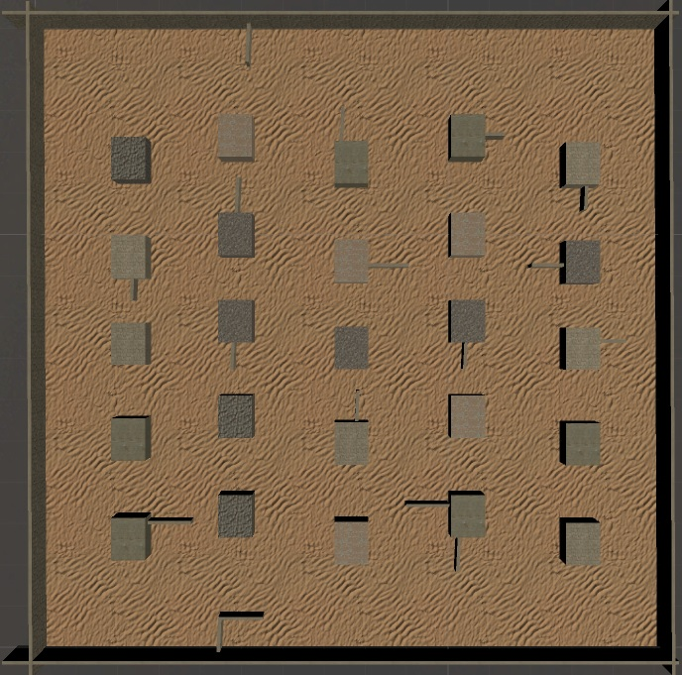

Side View:

# 

# 7 Players

## 7.1 Characters

Single Character that automatically spawns in at game start. Max 2 players.

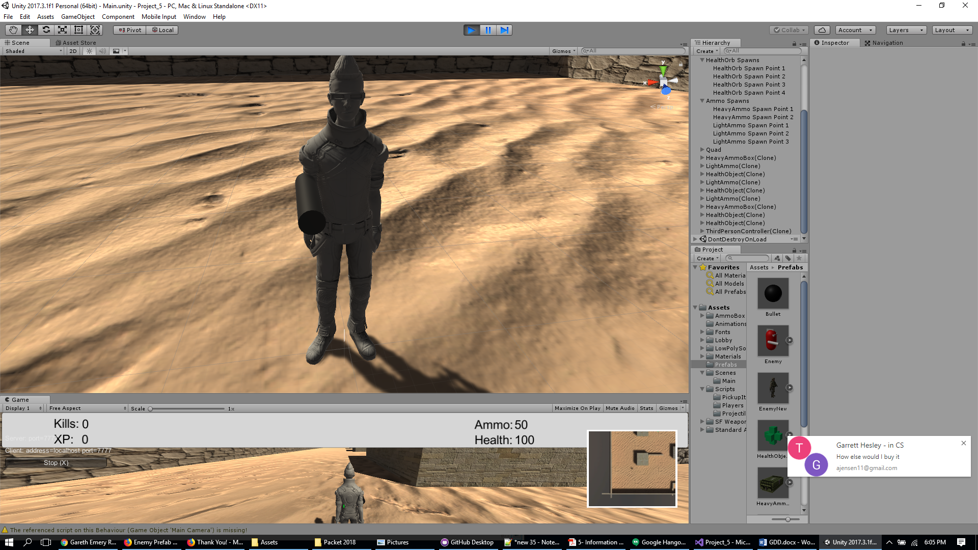

- Player is able to change their character’s color and name via the Lobby

## 7.2 Metrics

## 7.3 States

## 7.4 Weapons

# 8 NPC (optional)

## 8.1 Enemies

### 8.1.1 Enemy States

### 8.1.2 Enemy Spawn Points

## 8.2 Allies / Companions

### 8.2.1 Ally States

### 8.2.2 Ally Spawn Points

# 9 Art *

## 9.1 Setting

An extremely hostile desert urban city somewhere in the world.

## 9.2 Level Design

Level is based in a desert urban setting. The major elements the sand the units are walking on, and buildings that the players and enemies can use for cover. The player is able to pickup certain powerups items, which include health and ammo that are scattered around the level. When players and enemies spawn, or die and respawn, they spawn in the set locations below.

Level 1 – Spawn Points:

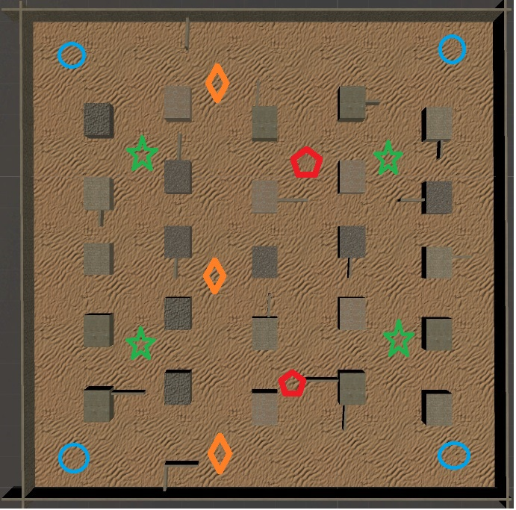

Blue Circle – Player/Enemy spawn

Green Star – Health spawn

Orange Triangle – Light Ammo spawn

Red Pentagram – Heavy Ammo spawn

Pick-up items:

**Health Orb:**

* Only able to pick up if not at full health.

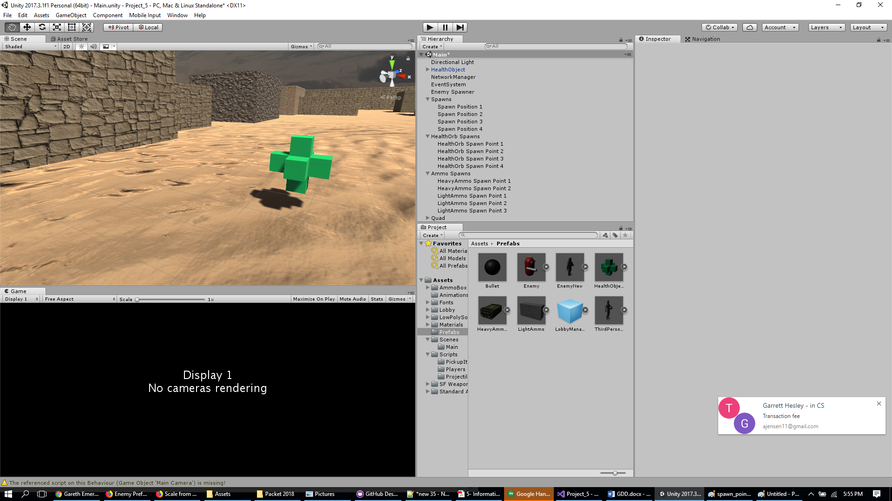

* +30 Health
* +30 Experience
* Respawns after 20 seconds

**Light Ammo:**

* Only able to pick up if not at full ammo.

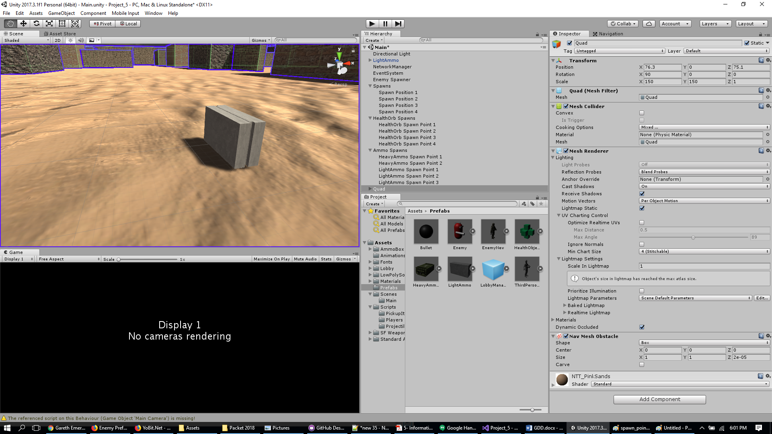

* +20 Ammo
* +10 Experience
* Respawns after 15 seconds

**Heavy Ammo:**

* Only able to pick up if not at full ammo.

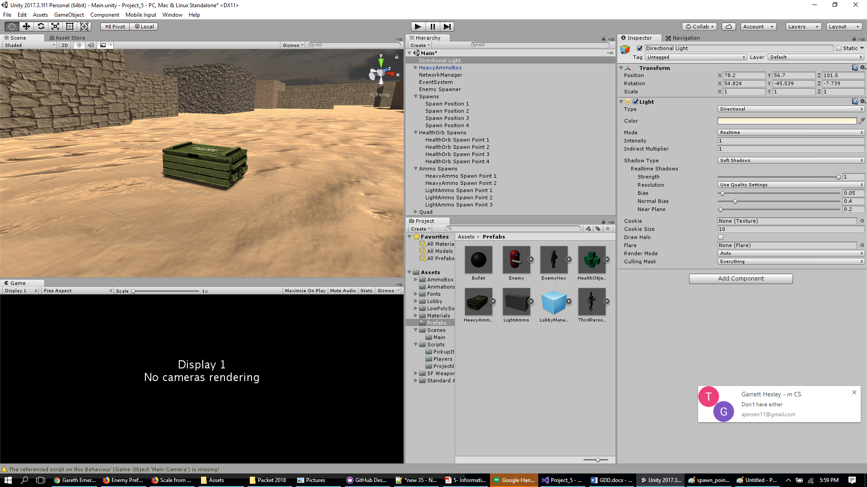

* +50 Ammo
* +20 Experience
* Respawns after 60 seconds

## 9.3 Audio

No audio implemented at this time.

9.4 What you Developed